1. 
2. In UML, we use generalization to express that one model element is based on another model element.
3. Generalization is represented by a solid line ending with one hollow arrowhead pointing to the parent class.
4. 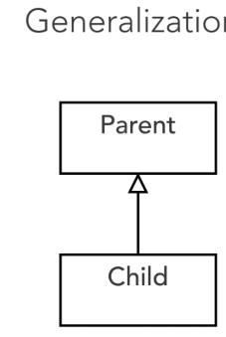
5. Let’s say we need a specialized class for Trip 🡺 BusinessTrip.
6. 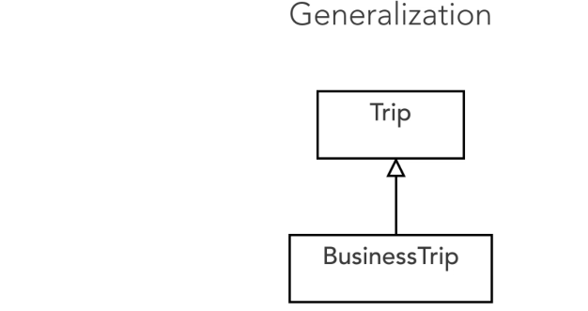
7. 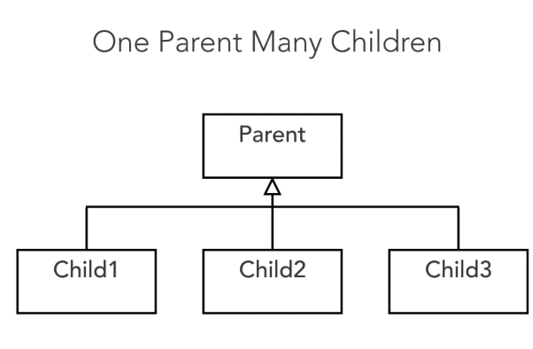
8. 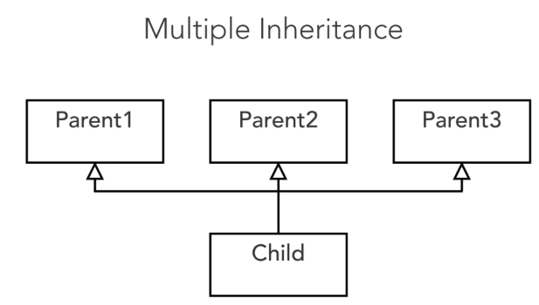
9. 